Why does the Aggregate Demand Curve slope downward? Gari Jenkins

The aggregate demand curve shows the relationship between the price level and output.  - The horizontal axis (Y) measures total economic output or GDP (the demand for goods and services by all sectors of the economy).  - The vertical axis (P) uses the overall price level for the economy as a measure of prices / price index.  The aggregate demand curve slopes downward, indicating that aggregate demand increases as the price level falls ie an inverse relationship between prices and output. (P ∝ 1/Y) | 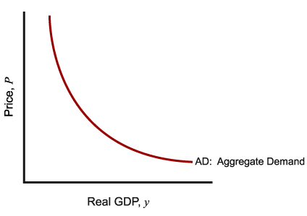
The Aggregate Demand slopes downward for several 3 main reasons.
Assume an increase in prices throughout . .
The Interest Rate Effect

Higher prices cause market interest rates to increase as lenders try to protect themselves from rising inflation rates. Increases in interest rates cause investment to decline (all things being equal) as the cost of borrowing rises. This reduces the Aggregate Expenditure and hence the output, through the multiplier effect.
As P↑ ⇒ M/p↓ ⇒ r↑ ⇒ I↓ ⇒AE↓ ⇒ AD↓ ⇒ Y↓ . . . . Therefore, P↑ ⇒ Y↓

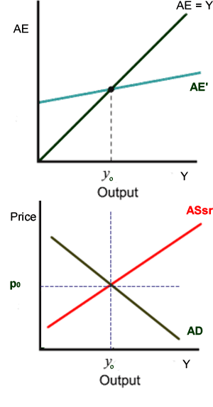
AE = C+I+G+X
AE’ = C+I’+G+X
y₁

If we now take the equilibrium position for P & Y (ie before we raised the price), we can plot this price-output pair on the diagram as shown (p₀,y₀)  .  After an increase in prices, we ended up at (p₁,y₁).  Again we can plot this. Already we can see the downward sloping effect. If we did this for all possible outcomes, we would end up with the curve as above | 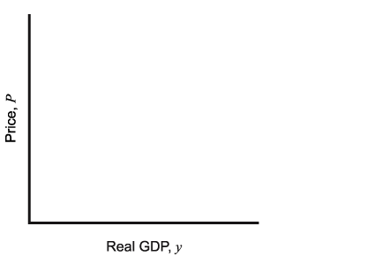  (p₀,y₀)  (p₁,y₁)  •  •

The Wealth Effect

As the price level rises, the real value of money decreases and people find that they are poorer.

Reality PRINCIPLE
What matters to people is the real value of money or income–its purchasing power–not the face value of money or income.

Higher prices lead to a decline in the market value of stocks, bonds, and other types of wealth. Changes in the value of wealth impacts the level of consumption, a component of aggregate demand (GDP). With higher prices we can expect consumption to fall due to the real balance effect.

As P↑ ⇒ C↓⇒ AE↓ ⇒ Y↓ . . . . .Therefore, P↑ ⇒ Y↓

The Net Export Effect

Higher domestic prices increase the price of exported goods sold in foreign markets. Furthermore, the relative prices of imported goods fall, leading domestic consumers to substitute part of their consumption in favour of the relatively cheaper imported goods. Assuming constant exchange rates, the overall impact of higher domestic inflation is to decrease net exports, further reducing aggregate demand.

As P↑ ⇒ X↓⇒ AE↓ ⇒ Y↓ . . . . .Therefore, P↑ ⇒ Y↓

In summary, higher prices cause aggregate demand to decline as three important components of aggregate demand are directly affected: consumption, investment, and net exports.

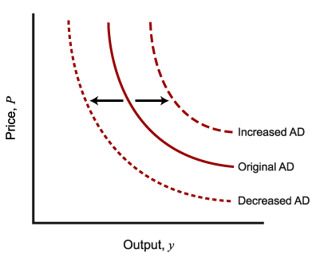
  Factors That Increase Aggregate Demand | Factors That Decrease Aggregate Demand
  Decrease in taxes | Increase in taxes
  Increase in government spending | Decrease in government spending
  Increase in money supply | Decrease in money supply

